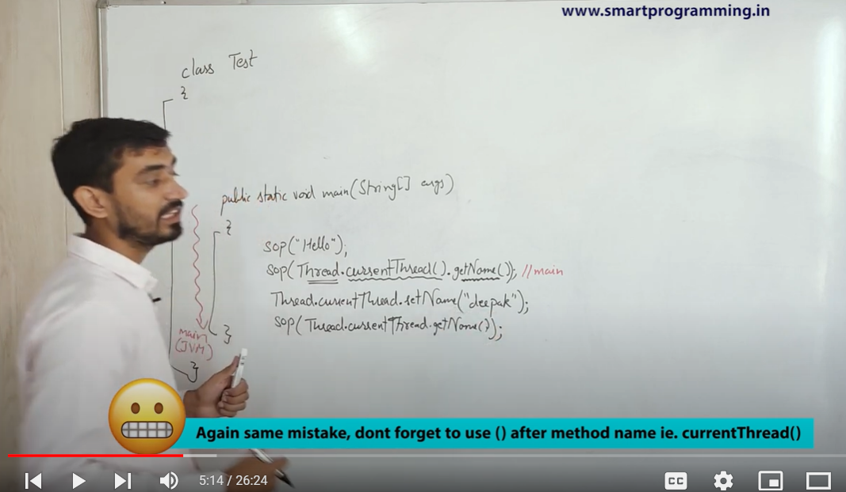

🡪 CurrentThread is a Static method so no need of object . Can be accessed using Thread class directly.It returns name , set names of the thread currently running .

A>>>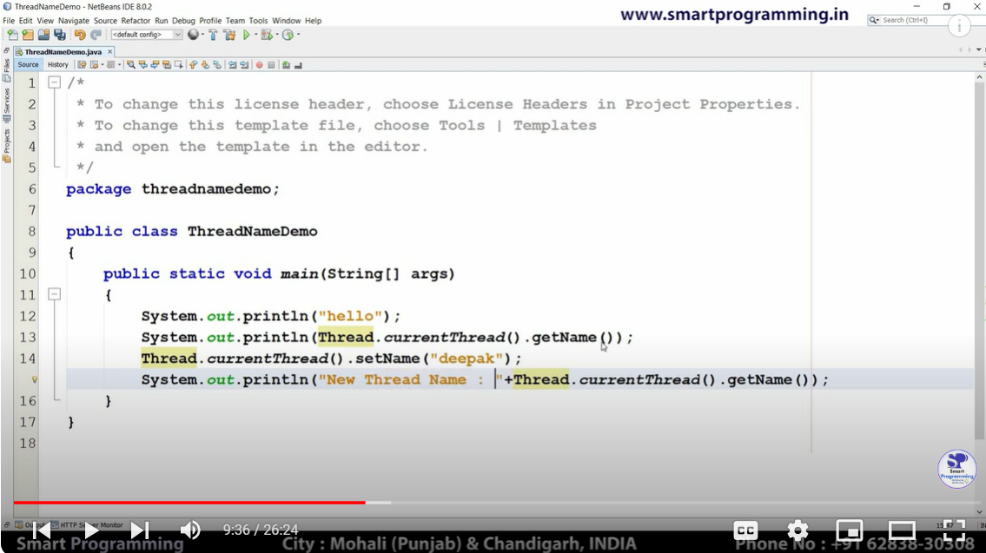

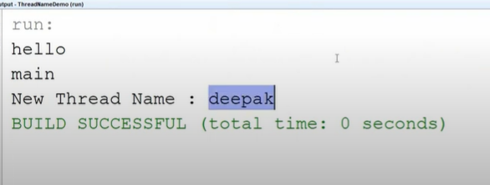

Changed main thread ( default provided by java ) name to Deepak .

B>>>

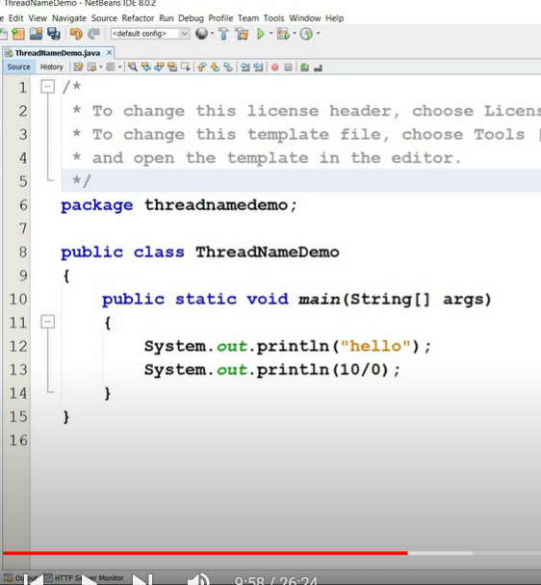

->Exception arithmetir error (10/0) in thread main - > output

Changing thread name to deepak: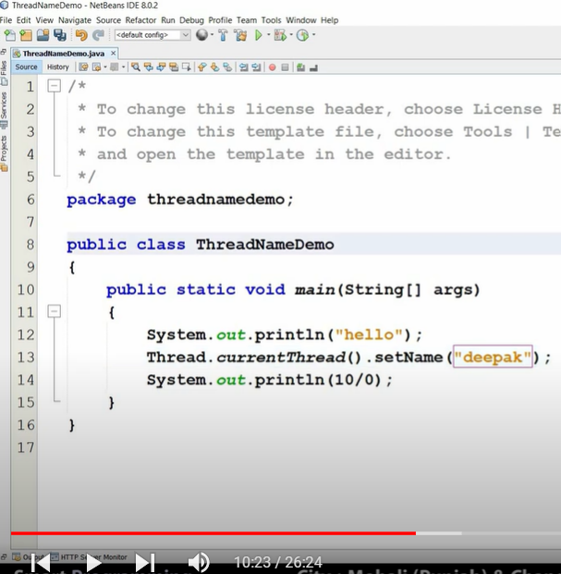

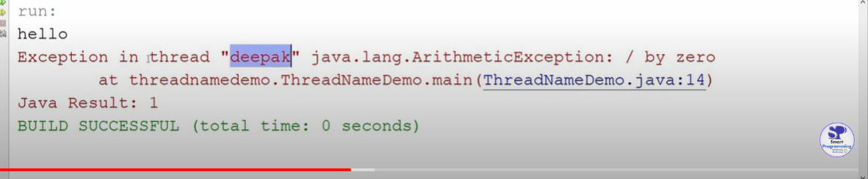

c>>

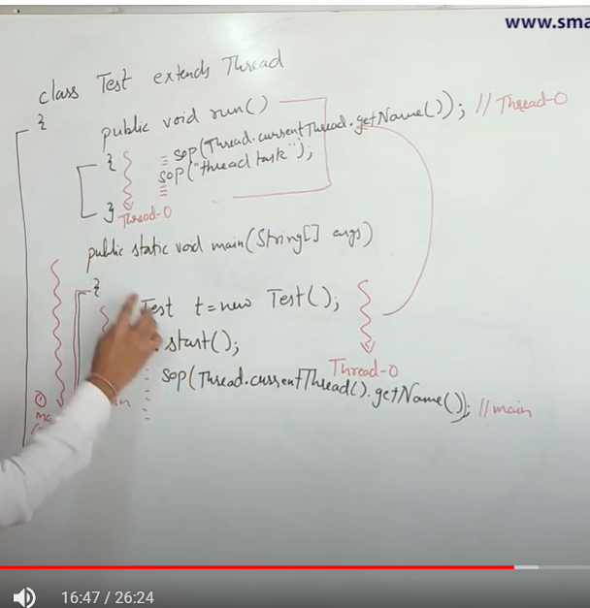

Facts :

i)When main () class is running ->sop prints main thread

ii)While run() class is running -> sop prints thread-0.

iii)Blocks inside main class are handled by main thread whereas the thread responsible to execute the code inside Run() method is thread-0.

Thread-0 is conventional name provided to jvm whenever a new thread is created. To give a

Different Name , you can use setname (“”).

D>>

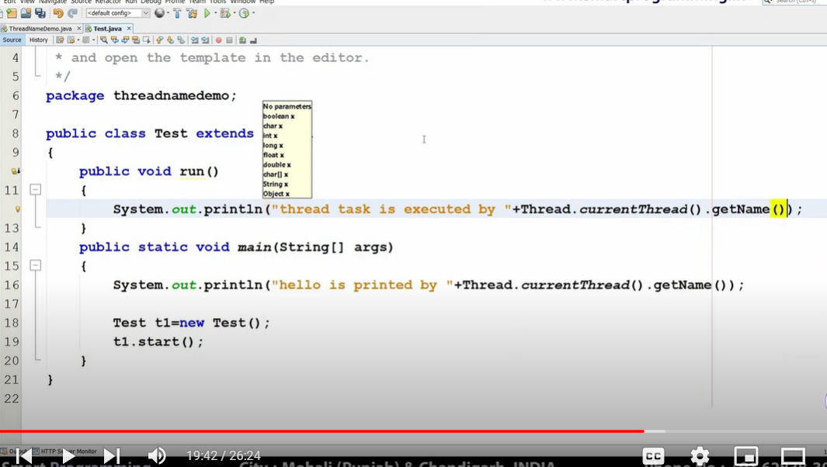

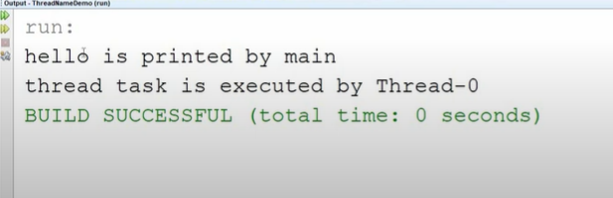

d>>

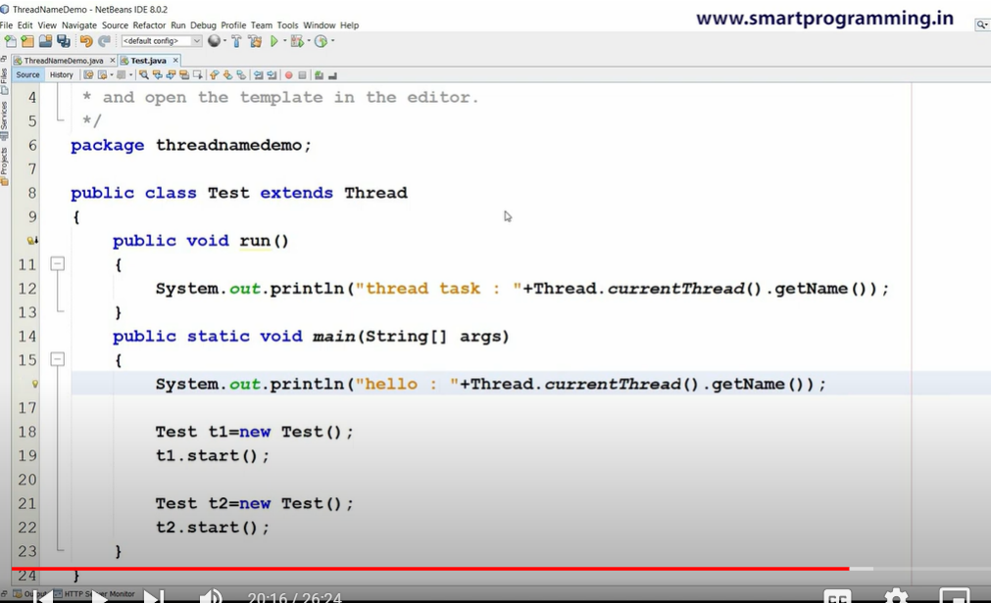

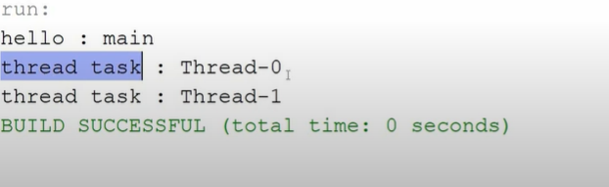

e>>

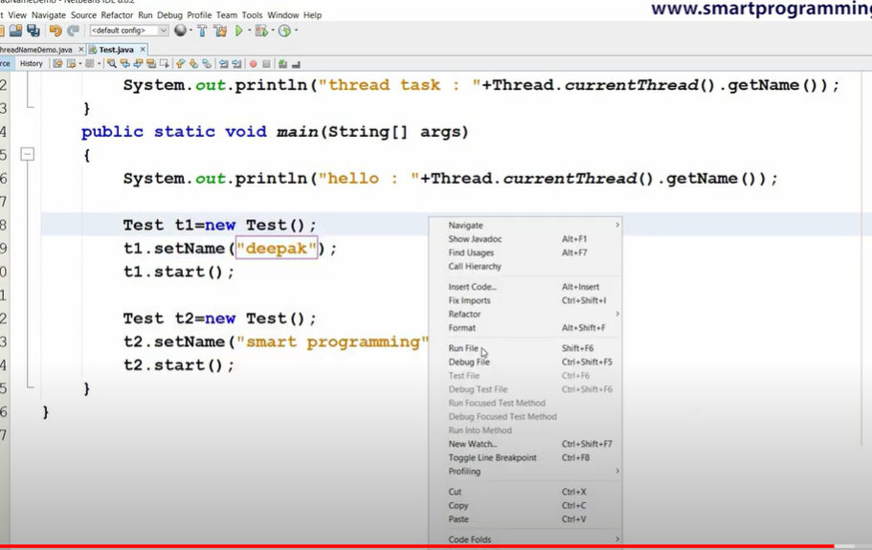

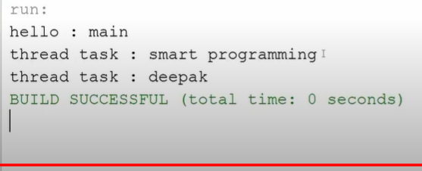

f>> 2 methods -> Direct use thread class and setname or use obj.setname() .Both works since object isinherited from Thread class.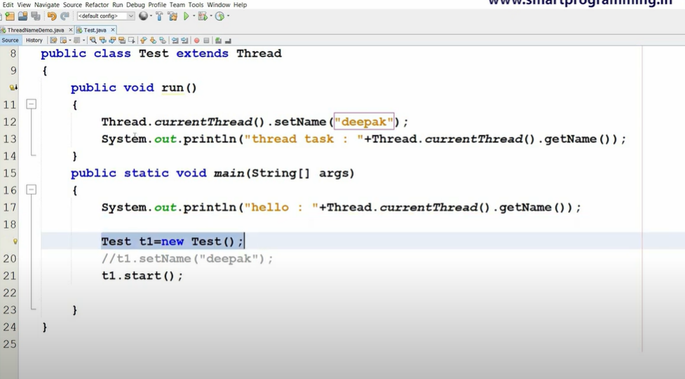

g>>

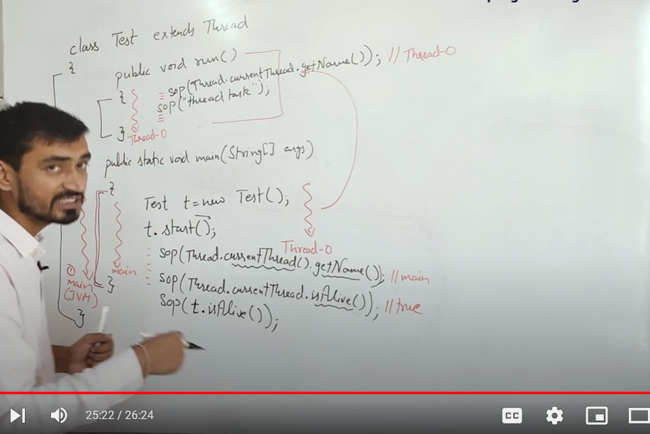

isAlive() methods return Boolean value whether Thread is in running or died state.

In above code , while executing inside main function ->

Getname() of current thread will return main thread since main method is being executed.

Now if we check is main method Alive - > Ans = yes since we are inside main method and it is still running.

Now if we check t.isAlive() after t.start() for an object , the resulting answer cant be predicted beforehand since any of the two case may exist depending on JVM , threading algorithms.